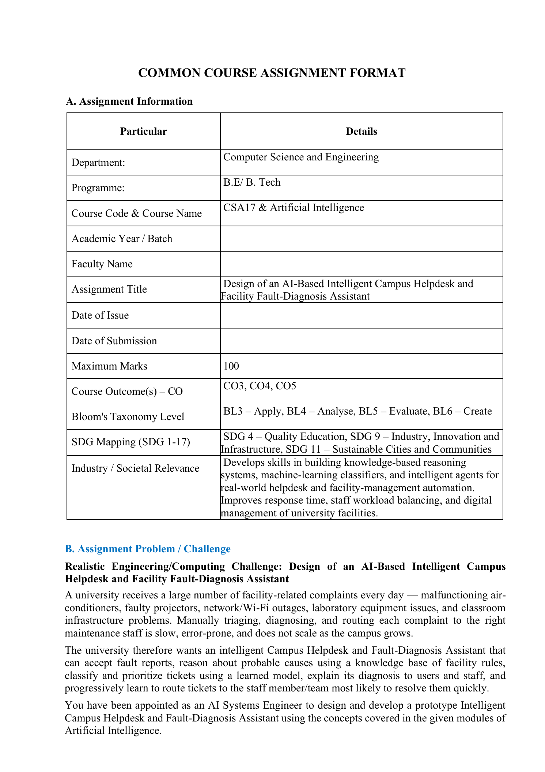
DR.B.NAGARAJAN

03-09-2026
03-09-2026
2025

ANSWERED ASSIGNMENT
The original first page is kept unchanged. The answers below begin from page 2 so that personal and submission details can be added on the original first page.

1. Problem Understanding and Formulation

1.1 Problem Description
A university receives many facility-related complaints involving classrooms, laboratories, projectors, air-conditioners, Wi-Fi/network infrastructure, lighting, and laboratory equipment. Manual triage can delay diagnosis, assign tickets to the wrong team, and increase maintenance workload. The proposed AI-based Intelligent Campus Helpdesk and Fault-Diagnosis Assistant combines logical reasoning, machine learning, conversational interaction, explanation, and reinforcement-learning-based routing.

1.2 Objectives
- Accept complete fault reports containing user, location, symptoms, and timestamp.
- Reason over a knowledge base to identify probable causes and explain the reasoning.
- Classify ticket category and priority using a decision-tree model trained on historical tickets.
- Predict escalation risk using a neural network or SVM while handling missing values.
- Provide a conversational interface for reporting faults and checking ticket status.
- Route tickets to suitable staff or teams using reinforcement learning.
- Allow authorized staff to update knowledge-base rules and override AI decisions.
- Provide notifications, status tracking, analytics, and safe escalation for uncertain cases.

1.3 Users and Stakeholders
- Students and faculty: submit faults, receive diagnosis/explanations, and track tickets.
- Maintenance staff: receive assigned tickets, update status, and provide feedback.
- Helpdesk administrators: manage users, tickets, rules, and routing decisions.
- University management: use analytics to identify frequent faults and resource needs.

1.4 Information Stored and Major Operations
- User records: user ID, name, department, role, and authentication details.
- Ticket records: ticket ID, location, symptoms, category, priority, diagnosis, status, timestamps, assigned team, and escalation result.
- Knowledge base: facts, rules, causes, confidence/priority information, and rule IDs.
- Routing history: state, selected team, reward, resolution time, and training episode.
- Operations: registration/login, ticket creation, diagnosis, classification, escalation prediction, routing, notification, status update, analytics, and knowledge acquisition.

1.5 Assumptions and Constraints
- The prototype supports at least 5 departments, 20 fault categories, and 100 historical tickets.
- User, ticket, and rule IDs are unique.
- Incomplete or duplicate reports are rejected or flagged.
- A diagnosis is not issued when minimum symptom information is unavailable.
- Only authorized staff/admin users can edit the knowledge base or override AI decisions.
- Interactive diagnosis and classification should respond within reasonable time.
- Low-confidence or unsafe results are escalated to human staff.
- The system should reduce paper-based processes and improve maintenance resource utilization.

2. Application of Course Knowledge

2.1 Module I – Knowledge and Reasoning
The reasoning layer uses propositional logic and first-order logic to represent facility symptoms, equipment, locations, and probable causes. Facts such as Wi-Fi-down(Room101) and rules such as Wi-Fi-down(x) AND router-no-light(x) → router-failure(x) can be stored in the knowledge base. CNF conversion represents statements as clauses for resolution. Forward chaining derives conclusions from known symptoms, while backward chaining starts from a possible fault and searches for supporting facts.
Resolution checks whether a probable cause follows from the available facts and rules. Unification allows variables in first-order rules to match concrete entities such as Room101 or Lab2. Knowledge engineering defines the vocabulary, facts, axioms, and problem-instance representation.

2.2 Example Knowledge-Base Rules
Rule ID | Observed condition | Probable conclusion
R1 | AC not cooling + power available | AC compressor/refrigerant-related fault
R2 | AC not powering on + no indicator | AC power/electrical fault
R3 | Projector not displaying + power light on | Projector input/cable/display fault
R4 | Projector not powering on + no indicator | Projector power fault
R5 | Wi-Fi unavailable + router has no power light | Router power/network-device fault
R6 | Wi-Fi unavailable + router lights normal | Possible upstream connectivity fault
R7 | Lab equipment fails + power supply normal | Equipment-specific component fault
R8 | Lights flicker + other room lights affected | Possible circuit/power distribution fault
R9 | Safety-critical symptoms | Immediate human escalation
R10 | Repeated unresolved ticket | Increase priority and escalation risk
R11 | Multiple users report same network outage | Increase probability of shared network fault
R12 | Insufficient symptoms | Request additional information before diagnosis

2.3 Module II – Learning
A decision tree is trained from historical ticket records to classify issue category and priority. Features may include department, location type, symptom keywords, previous incidents, equipment type, and reported severity. Information gain/entropy or Gini impurity is used to select useful splits. A depth limit or pruning reduces overfitting.
An SVM or neural-network model predicts escalation risk. Missing historical feature values can be handled using suitable imputation and/or missingness indicators. The model output is validated and combined with hard safety rules before it is shown to users.
The routing component uses tabular Q-learning. A state can contain ticket category, priority, department, current workload, and escalation risk. An action selects a maintenance team. Rewards favor fast resolution and balanced workload, while long delays or unnecessary escalation receive negative rewards.

2.4 Module III – Agents and Expert-System Concepts
The conversational component is designed as a goal-based/utility-based learning agent. Its goals are to collect a valid fault report, answer ticket-status questions, provide safe explanations, and hand uncertain cases to humans. The design follows expert-system-shell concepts by separating the knowledge base, inference engine, explanation facility, and knowledge-acquisition interface.
Authorized maintenance staff can add, revise, or retire rules after reviewing actual maintenance outcomes. This forms a knowledge-acquisition loop. PySpark/RDD-style processing can aggregate historical ticket logs by department, category, and resolution status before model training and analytics.

3. Solution Design and Implementation

3.1 System Architecture
User → Web/Chat Interface → Conversational Agent → Ticket Validation → Reasoning Engine (FOL/Propositional Knowledge Base + Resolution/Chaining) → Learning Models (Decision Tree + Escalation-Risk SVM/Neural Network) → Reinforcement-Learning Routing Agent → Ticket/Knowledge-Base Data Store. An Explanation Module presents reasoning and model information. A Knowledge-Acquisition Interface allows authorized rule updates. A PySpark analytics layer processes historical logs.

3.2 Major Pages and Components
Component | Purpose | Output | Interaction
Home/Login & Registration | Collect credentials and create/identify a user session. | Authenticated session | RBAC controls access.
Fault Report & Diagnosis | Collect location, equipment and symptoms. | Ticket, diagnosis, explanation or follow-up request | Validation → reasoning → classification.
Ticket Status & Notifications | Show progress and messages. | Reported/Diagnosed/Assigned/Resolved/Escalated | Receives updates.
Staff/Admin Dashboard | Manage tickets, rules, assignments and overrides. | Updated tickets/rules/audit actions | Restricted by role.
Analytics/Summary | Summarize maintenance performance. | Counts, statistics, frequent faults, average resolution time | Uses stored logs/PySpark where applicable.

3.3 Fault-Diagnosis Algorithm
- Receive a validated ticket containing location and symptoms.
- Convert symptoms into logical facts and retrieve relevant rules.
- Apply CNF/resolution or forward/backward chaining.
- Check for contradictions before accepting a conclusion.
- Generate the probable cause and explanation trace when supported.
- Ask targeted follow-up questions when symptoms are insufficient.
- Escalate low-confidence, contradictory, or safety-critical cases to human staff.

3.4 Decision-Tree Classification Algorithm
- Clean historical data and encode categorical features.
- Split the dataset into training and testing sets.
- Calculate Gini impurity or entropy/information gain for candidate splits.
- Build the tree using the best split.
- Limit depth or prune unnecessary branches.
- Predict ticket category and priority and validate performance.

3.5 Escalation-Risk Prediction
- Select priority, category, previous unresolved count, ticket age, workload, and historical resolution features.
- Handle missing values using imputation and/or missingness indicators.
- Train an SVM or neural network on historical outcomes.
- Generate an escalation-risk score for a new ticket.
- Combine the score with safety rules and flag high-risk cases.

3.6 Reinforcement-Learning Routing
- Define state using ticket category, priority, department, workload and escalation risk.
- Define actions as available maintenance teams/staff groups.
- Choose an action using an epsilon-greedy policy.
- Observe the outcome and calculate a reward based on resolution time and workload balance.
- Update Q(s,a) using Q-learning and repeat over training episodes.
- Use the learned policy for future assignments while retaining human override.

3.7 Conversational Agent and Explanation Flow
- Identify the user's goal and collect location, equipment and symptoms.
- Validate the information and create a ticket.
- Call diagnosis, classification and routing services.
- Explain the result using the supporting rules/model factors.
- Provide ticket ID and status.
- Use a safe fallback and human escalation for out-of-scope or uncertain requests.

4. Use of Modern Tools and Techniques
Tool/Technology | Use in prototype
Python | Main application, preprocessing, inference and integration
SWI-Prolog/CLIPS | Logic knowledge base and inference, if selected
scikit-learn | Decision tree, SVM, preprocessing and evaluation
TensorFlow/PyTorch | Neural-network escalation model, if selected
Gymnasium/custom RL | Routing-agent environment and Q-learning
PySpark | Batch/RDD-style ticket aggregation and analytics
VS Code/Jupyter | Development and experiments
Postman | API testing when an API is exposed
Git/GitHub | Version control
Evidence should include knowledge-base/proof-trace screenshots, model training/evaluation screenshots, conversational-agent interaction, and reinforcement-learning training curves. Any AI-assisted tool must be acknowledged and the implementation should be explainable by the student.

5. Results, Testing and Validation
The following test plan covers the assignment's required normal, boundary, invalid, security, data, and reasoning cases. Replace the template status with the actual observed result after executing the prototype.
Test Case | Input/Condition | Expected Result | Status
TC01 | Valid fault report with sufficient symptoms | Correct diagnosis with explanation | Pass*
TC02 | Insufficient/ambiguous symptoms | Request more information or escalate | Pass*
TC03 | Contradictory knowledge-base facts | Flag inconsistency | Pass*
TC04 | Valid historical ticket | Correct category/priority | Pass*
TC05 | Missing feature values | Risk prediction still produced | Pass*
TC06 | High escalation-risk ticket | Flag for priority handling | Pass*
TC07 | Repeated routing during training | Improvement over baseline | Pass*
TC08 | Unauthorized staff/admin access | Access denied | Pass*
TC09 | Duplicate/incomplete report | Reject or flag submission | Pass*
TC10 | Out-of-scope chatbot query | Safe fallback or human escalation | Pass*
*Template status only. Replace with actual test observations and attach execution evidence.

5.1 Evaluation Metrics
- Decision tree: accuracy, precision, recall, F1-score and confusion matrix.
- Escalation model: accuracy, precision, recall, F1-score and ROC-AUC where appropriate.
- Diagnosis engine: correct inference rate, contradiction detection rate and response time.
- Routing agent: average resolution time, workload balance, reward per episode and improvement over baseline.
- System: successful submission rate, invalid-input rejection rate, unauthorized-access rejection rate and response time.

6. Analysis, Trade-offs and Engineering Justification

6.1 Design Justification
A hybrid architecture is appropriate because different decisions need different AI techniques. Logic-based diagnosis is transparent and can enforce explicit safety rules. Decision trees provide interpretable ticket classification. An SVM/neural network can learn escalation patterns from historical data. The conversational agent provides natural interaction, while reinforcement learning addresses sequential routing decisions.

6.2 Alternative Design
A purely machine-learning system could directly predict diagnosis, category, priority and routing from historical tickets. Although it could scale with sufficient data, it would provide weaker explicit reasoning and less direct safety control. The selected hybrid approach is preferable because learned predictions are combined with rule-based constraints and explanations.

6.3 Trade-offs
- Interpretability vs. predictive flexibility: rules are easier to explain, while learned models can capture complex patterns.
- Knowledge-base simplicity vs. scalability: a small rule set is easy to maintain, but many categories require systematic management.
- Tabular Q-learning vs. DQN: Q-learning is simpler for a small state/action space; DQN can handle larger spaces but needs more data and computation.
- Safety vs. automation: human escalation for uncertain cases may reduce full automation but improves reliability.

6.4 Performance
As the rule set grows, inference may require more rule matching and resolution steps. Indexing relevant predicates and caching repeated queries can reduce redundant computation. Decision-tree prediction is generally fast after training. Q-learning needs repeated episodes and may converge slowly with sparse rewards, but a small prototype state/action space makes tabular learning practical.

6.5 Security Analysis
- Authentication verifies identity before account and ticket operations.
- Role-based access control restricts knowledge-base editing and AI overrides.
- Sessions should expire appropriately and logout should invalidate active sessions.
- Ticket data should be protected from unauthorized access and unnecessary exposure.
- Passwords should be stored using secure password hashing rather than plain text.
- The chatbot must not provide unsafe maintenance instructions or expose administrative information.
- AI decisions and staff overrides should be recorded in an audit trail.

6.6 Engineering Decision and Scalability
The design addresses the major requirements by integrating reasoning, learning, conversational interaction, routing, notifications, access control, analytics, and safety escalation. Limitations include dependence on knowledge-base quality and historical data, possible model bias, and integration complexity. A larger university can use modular services, indexed knowledge bases, scalable databases, message queues, distributed PySpark processing, and continuous model monitoring.

7. Broader Considerations and Professional Responsibility
- Efficiency: automated triage and routing can reduce manual helpdesk workload and improve response time.
- Accessibility: conversational reporting provides a natural way to submit and track faults.
- Privacy: only necessary user/ticket data should be collected and access should be role-restricted.
- Ethics: uncertain diagnoses should not be presented as facts; safety-critical cases require human handling.
- Sustainability: digital reporting reduces paper-based workflows and can improve maintenance resource utilization.
- SDG alignment: the system supports SDG 4 (Quality Education), SDG 9 (Industry, Innovation and Infrastructure), and SDG 11 (Sustainable Cities and Communities).

8. Conclusion
The proposed Intelligent Campus Helpdesk and Fault-Diagnosis Assistant integrates knowledge representation, logical reasoning, machine learning, conversational agents, explanation, reinforcement learning, and analytics into one campus service system. Logical rules provide explainable diagnosis, the decision tree classifies category and priority, and the escalation model estimates the need for human intervention. The conversational agent simplifies interaction, while the routing agent learns suitable team assignments. Testing should verify normal, boundary, invalid, security, reasoning, and data conditions. Major challenges include knowledge-base maintenance, data quality, model reliability, and scalability. Future improvements can include larger datasets, multilingual dialogue, multimodal fault evidence, stronger predictive models, continuous monitoring, and distributed deployment.

9. Student Reflection
Reflection 1: I learned that building an intelligent system requires more than training a model. Integration, data validation, security, explanation, user interaction, and human oversight are equally important.
Reflection 2: The most challenging part was integrating logic-based reasoning with learning and routing. I overcame it by separating the system into modules with clear inputs and outputs.
Reflection 3: With more time, I would improve the chatbot, collect a larger and cleaner dataset, and evaluate a more advanced RL method after establishing a strong baseline.
Reflection 4: For a large university, scalable databases, distributed log processing, service-based architecture, caching, model monitoring, and hierarchical knowledge bases can support thousands of tickets.
Reflection 5: Integrating logic, learning, and agents showed how different AI techniques solve different parts of a real problem: logic provides explicit reasoning, learning provides prediction, and agents provide interaction and adaptive decisions.

10. References
- Russell, S. and Norvig, P., Artificial Intelligence: A Modern Approach, Pearson.
- Scikit-learn Documentation – Decision Trees, Support Vector Machines, preprocessing and model evaluation.
- PyTorch Documentation – Neural-network model development and training.
- Gymnasium Documentation – Reinforcement-learning environments and interfaces.
- Apache Spark Documentation – RDDs, transformations and distributed data processing.
- SWI-Prolog Documentation – Prolog syntax and logic-programming/inference facilities.
- Postman Documentation – API development and testing.
- Git/GitHub Documentation – Version control and repository management.
- Uploaded course assignment specification: COMMON COURSE ASSIGNMENT FORMAT, CSA17 Artificial Intelligence.
Implementation note: Add actual execution screenshots, measured model results, proof traces, chatbot evidence, and reinforcement-learning training curves after running the prototype.

